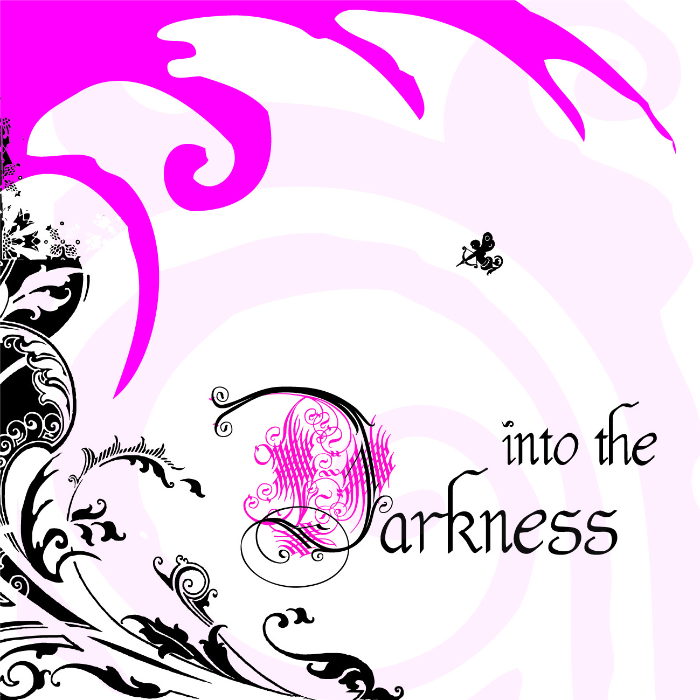

*Stage Zero*

Contemporary Art Group Exhibition

*Curated by Adriana M. Soldini*

14th JUL 2012 / 31st AUG 2012

Cell63 artgallery

Allerstraβe 38 / Berlin

*Vernissage*

Saturday, 14th July 2012 / 8 p.m.

Sta diventando buio nella mia mente

It’s becoming dark inside my mind  
  
(*Into the Darkness, Meganoidi*)

*Press Release No. 1, 14th April 2012*

The *incipit* of a song by ***Meganoidi***, published at the beginning of the new millennium, is the starting point for the work of a group of artists whose aim is to represent the **dark vein** of the ***Neo Pop*** body. The new reality is not an art movement, but it flows between movements, without arrogant elitisms and any kind of bond except for the adherence to the concept, which triggers off a temporary or permanent collaboration.

The input came from **Roberto Messina,** artist, who chose **Adriana M. Soldini**, curator and art narrator, to manage the project. Together they selected a group of artists whose works share the same purposes.

The following artists and groups were invited to participate: Anonymous Art, Arts Factory, Loredana Catania, Massimo Festi, Shanti Ranchetti, Francesca Randi. They form the core of the project, which is bound to grow in the future.

The **Dark** will be expressed in the typical Neo Pop style – grotesque, sarcastic and intriguing – and several artistic media will be employed. It will mainly deal with current topics, with music and literature, in order to represent an imagery which is often sick, the metaphor of a society whose values are in crisis, a hypocritical society with a disquieting dark side, to which the group will keep up attention.

The distinctive feature will be the **ex-voto**, meant as a source that testifies a situation and tells a tale: a homage to something or somebody by virtue of shared ideas and actions; a celebration of an event; the visual expression of a wish or a promise.

Stage Zero is ***Into the Darkness***, a group exhibition which will be hosted by the **Cell63 artgallery in Berlin**, Allerstraβe 38, **since the 14th of July until the 31st of August 2012**.

**Anonymous Art** (Elena Bertoni, Simone Romano), **Arts Factory** (Francesca Del Moro, Federica Gonnelli, Donatella Schilirò, Adriana M. SoldinI), **Loredana Catania**, **Roberto Messina**, **Shanti Ranchetti** are invited to deal with Darkness and its symbiotic relationship with Light.

Inside the mechanics of society, men are inclined to hide their negative and condemnable sides in the attempt to be accepted and integrated. They spend a lot of energy to smother and hide them, until the forced balance dramatically breaks. French sociologist **Michel Maffesoli** describes it as a revival of the dark face of our nature, that culture can only partially tame but that keeps on enlivening all our affections.

Darkness is not only the image of Evil. It also means **change** towards a renewal, like the alchemist’s *Nigredo*. It can be connected with the **dark night** of the soul – a term spread by Giovanni della Croce who, together with S. Teresa d’Avila, made the great mystic couple of the sixteenth century – which is full of difficulties and problems but necessary in order to reach the light of the union with God. Another mystical world, that of the **Kabbalah** and of **Hasidim,** goes as far as to identify darkness with “the great reservoir of Light”.

We shouldn’t forget that the human being is born in the darkness of the **maternal womb** and that he is

supposed to keep this dimension inside himself for all his life long. Like the symbolism of the **dark earth**

from which man emerged, becoming impregnated with it, and where he goes back after death..

Even the **night** itself is far from being somber, as its darkness contains dreams and stars. We can’t help thinking of the **dark matter** that in our Universe is much more extensive than the visible one, like the **dark energy** that flows everywhere.

And what is the role of **Shadow** in such a context?

“…where would all your good be if *evil* did not exist? What would the earth look like without shadows? Objects cast shadows, and people too. Here is the shadow from my sword, but there are also shadows from trees and living creatures. Or would you strip the entire globe of trees and living things to fulfill your fantasy of basking in barren light? You are a fool”. This is what Bulgakov's Woland-Mephistopheles tells Yeshua's disciple Matthew Levi in Bulgakov’s masterpiece *The Master and Margarita* (translation by Michael Karpelson, Lulu Press, p. 281).

The concept’s development is based on an extensive research which goes from Plato’s "Allegory of the cave"to the concept of Shadow as formulated by **Carl Gustav Jung**.

From Good to Evil, the artists are supposed to explore the depths of the human soul and of the structures of society. They are challenged to catch the moment in which Darkness appears inside the human mind. For this

purpose they will use the lightness and the magic that Neo Pop only shares with fairy tales.

Afterwards, Arts Factory, Massimo Festi and Francesca Randi will bring the second event of the artistic project to Italy. Its title will be *Pop Express in the Dark Night*.

The Berlin exhibition will be open to the public:

Tue > Fri 2 p.m.- 7 p.m. + 2nd & 4th Sat/Month

*Cell63 artgallery*

Allerstraβe 38

12049 Berlin

U8 Leinestraβe

*Info*

+49(0)30.21973329  
[info@cell63.com](mailto:info@cell63.com)

[www.cell63.com](http://www.cell63.com)